[**Griffiths**](https://docs.google.com/document/d/1Hmlp39B4ErLKe3b8TO1vQpZW5r9T0sCYiy9b404jAr8/edit?usp=sharing) **et al,**

**FIGURE 1**. A) Study site at Calvert Island BC. B) Choked pass, site of experimental transplants and surveys of *Smithora* *naiadum* and *Zostera marina.* Eight sites in the meadow were surveyed using 40 m transects. C) *Smithora* biomass / *Zostera* biomass at edge vs interior (circled) sites (n = 4); differences were significant (P < 0.001). The site of the reciprocal transplant is WF (lower left).

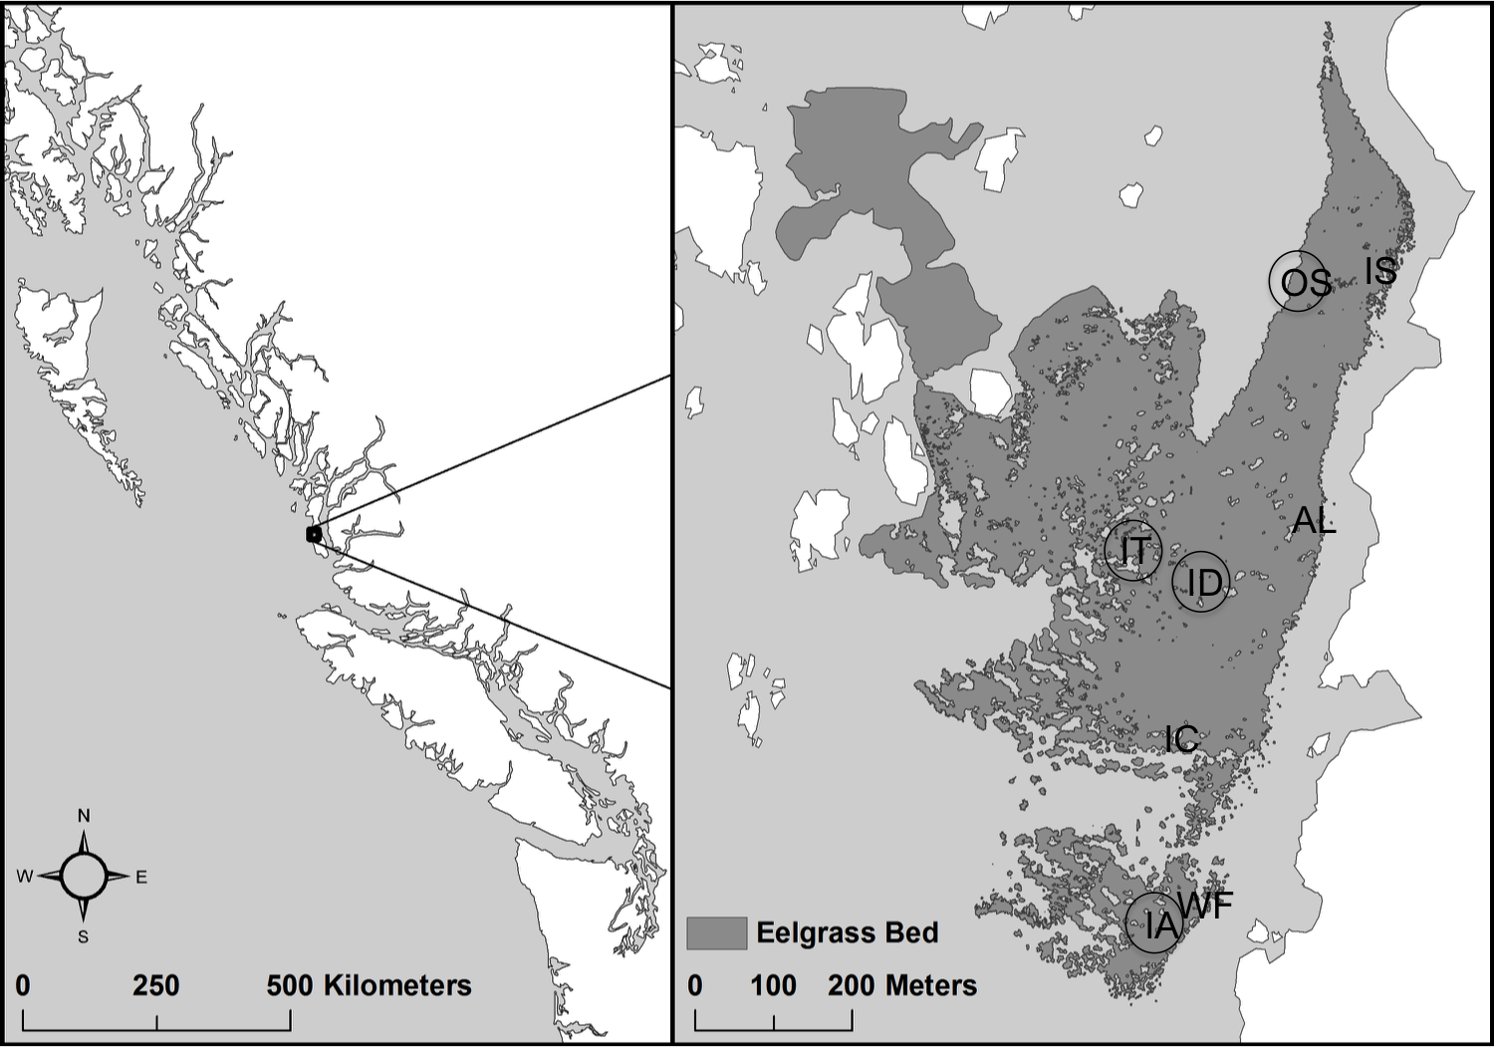

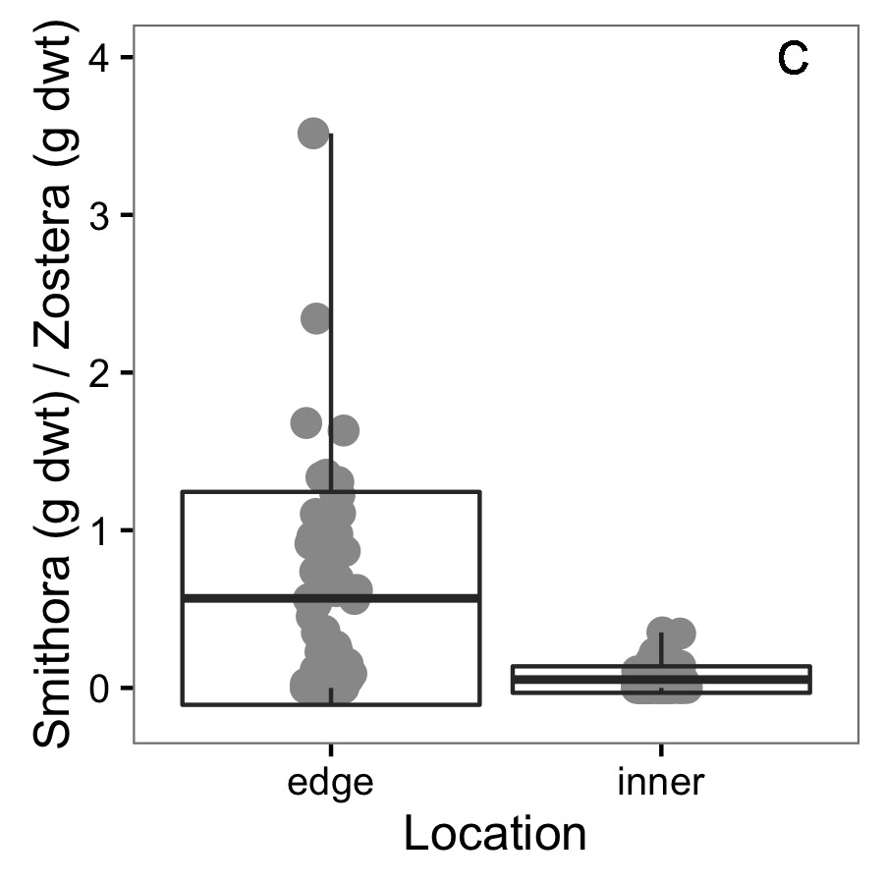

**Table 1.** Sample sizes for the experiments and treatment levels in the reciprocal transplant experiment. Biomass could only be measured on shoots following transplant but all shoots were swabbed before and after. Edge and Interior refer to high and low *Smithora* load respectively (Figure 1C), as well as their position in the seagrass meadow.

**Test and Treatments Measurement level Sample Size**

*Smithora Biomass & Microbial Community*

Edge Experiment After Shoot 3

Interior Experiment After Shoot 3

Edge Control After Shoot 5

Interior Control After Shoot 4

Edge Ambient Shoot 2

Interior Ambient Shoot 2

*Just Microbial Community*

Edge Experiment Before Shoot 3

Interior Experiment Before Shoot 3

Edge Control Before Shoot 5

Interior Control Before Shoot 4

**Figure 2.** Conditions at the two experimental transplant sites (WF and IA) before the experiment in June 2015. For six replicate samples of 0.0625 m2 of seagrass meadow, A) *Z. marina* dry weight of above ground biomass, B) *Smithora* dry weight biomass (per *Z. marina* shoot biomass) C) grazer abundance / g eelgrass shoots, and D) seagrass surface bacterial assemblages varied significantly. See appendix for grazer composition comparison.

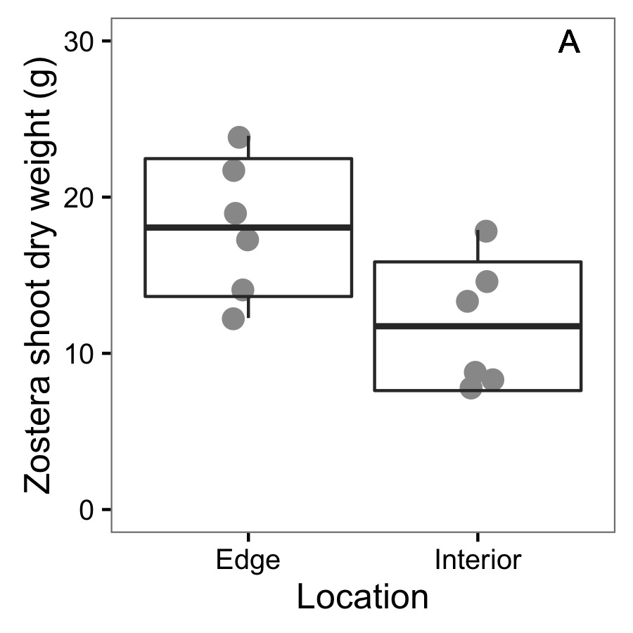 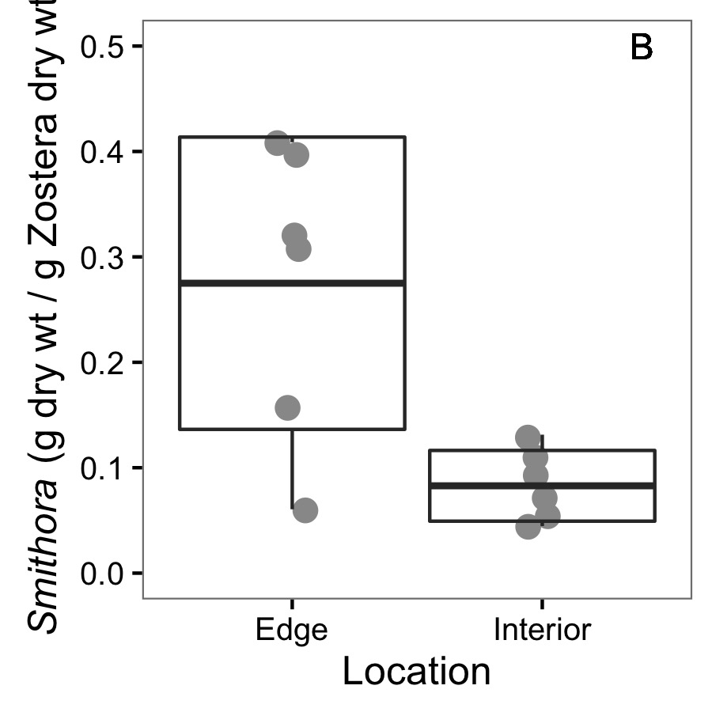

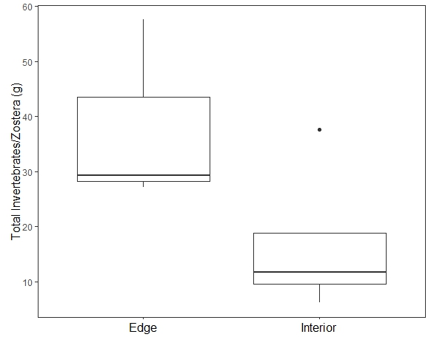

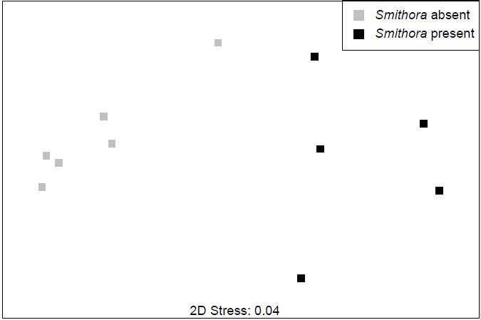

**can this panel have a main title or legend, so it’s immediately clear that it’s grazers? And, somewhere (appendix) do we give the species driving these differences?**

**Figure 3**. Final *Smithora* abundance (g / g *Zostera* dry wt) for experimental and control shoots in the reciprocal transplant experiment. Box indicates mean and 1 standard deviation.

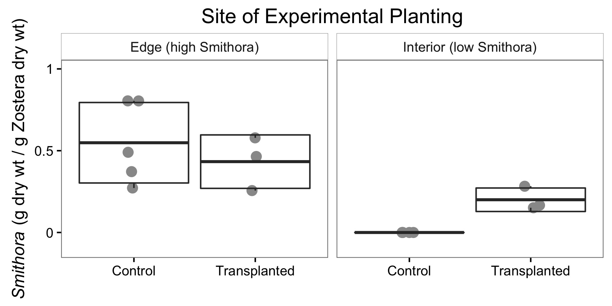

**my notes: so, the shoots with more smithora from the edge did not lose it, or gain more. So lack of grazers in interior doesn’t explain trends. Smithora from interior gained it, suggesting colonization was the factor (eliminating grazing).**

**We can consider colonization as propagule supply, or as bacterial environment (shoot characteristics).**

**Figure 4**. Bacterial assemblages after transplant with treatments indicated.

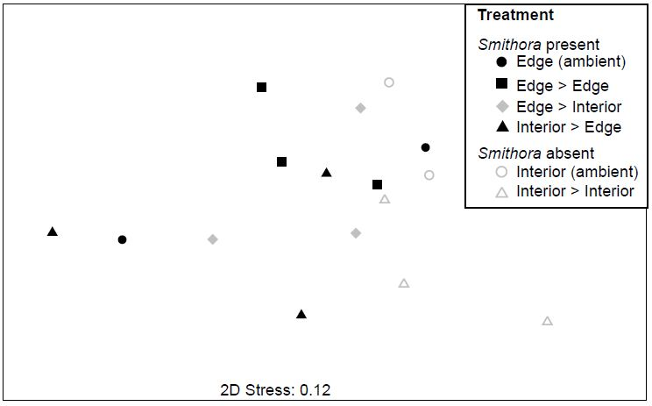

**APPENDIX:**

Figure A1: *Zostera marina* shoot density at transplant sites.

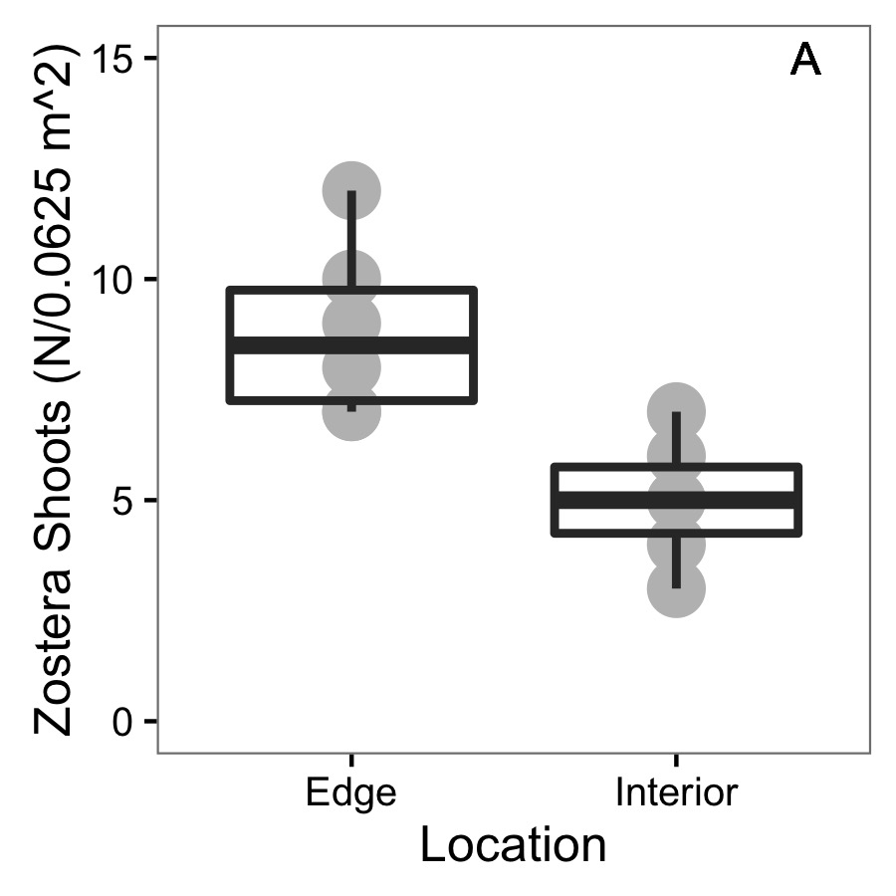

Figure A2: NMDS for grazer assemblages at transplant sites before experiment. Red hull is interior and grey hull is edge. Stress is 0.2873149.

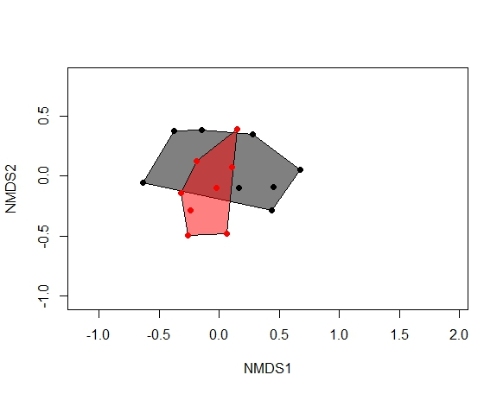

Figure A3: NMDS for grazer assemblages on non-experimental shoots at transplant sites before and after experiment. Red hull is June and grey hull is July. Stress is 0.2873149.

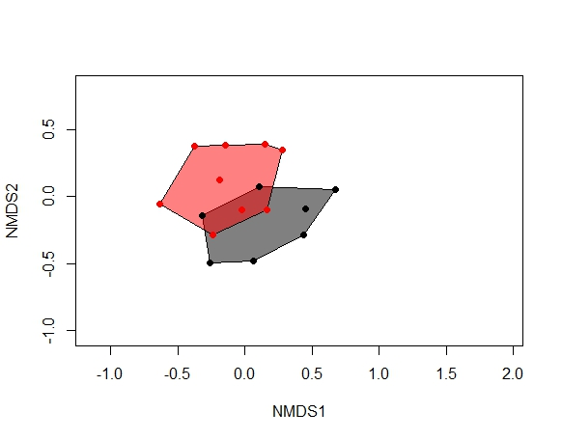

Figure A4. Bacterial composition of transplanted shoots plots grouped to order.

